Basic SQL Injection
Proof of Concept Report — HackViser Lab
Prepared by: Aakash Singh | Date: May 31, 2026

Vulnerability Information

Author | Aakash Singh
Date | May 31, 2026
Lab | Basic SQL Injection
Platform | HackViser
Vulnerability Type | SQL Injection
Severity | Critical
CWE | CWE-89
Impact
An attacker can inject malicious SQL queries to bypass authentication controls, gaining unauthorized access to user accounts including admin accounts. This may lead to full account takeover and sensitive data exposure.
Reproduction Steps
Step 1: Navigate to the login page of the target application.
Step 2: Enter a SQL injection payload in the username field: ' OR '1'='1
Step 3: Observe that the application authenticates without valid credentials — account takeover achieved.
Evidence Screenshots
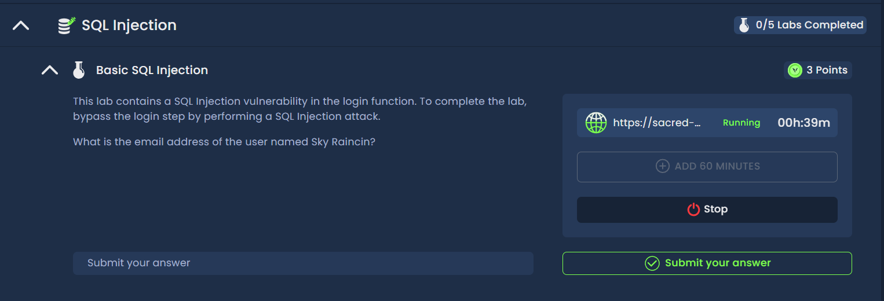
Figure 1: Login page — entering SQL injection payload
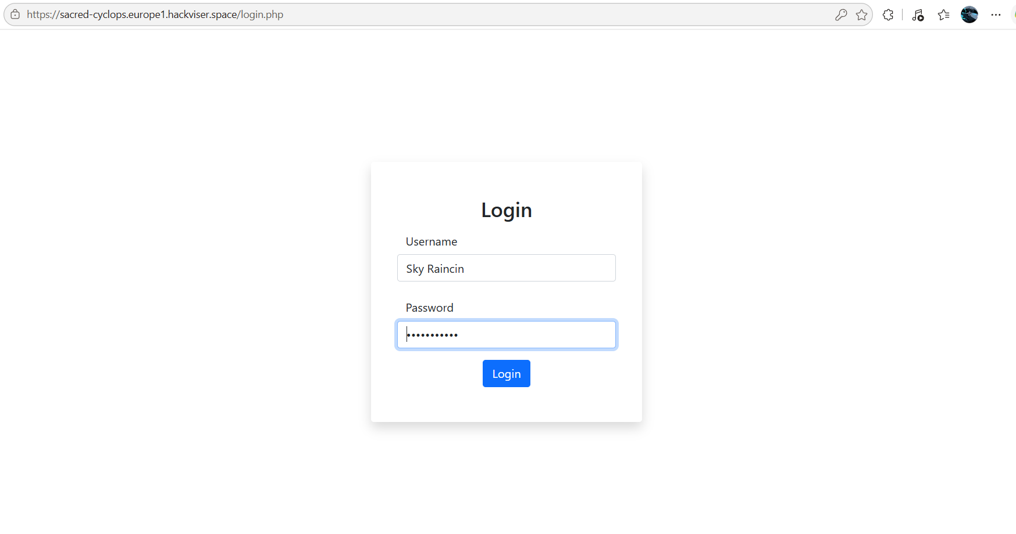
Figure 2: SQL payload ' OR '1'='1 — user credential bypass
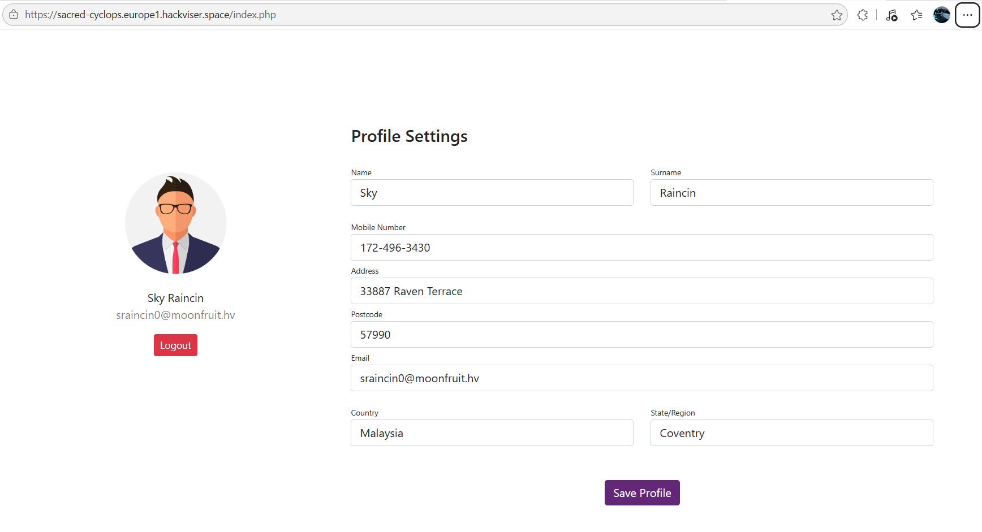
Figure 3: Successful account takeover confirmed
Remediation
Use parameterized queries or prepared statements. Implement strict input validation on all user-supplied fields. Apply principle of least privilege on database accounts.
Confidential — Prepared by Aakash Singh | Security Research POC

